**Institute of Engineering & Management**

**Department of Computer Science & Engineering**

**Communication Engineering Laboratory for 2nd year 4th semester 2018**

**Code: CS 491**

**Date:** 22/3/2018

**ASSIGNMENT- 7**

**Experiment Name:** To generate amplitude modulated wave and determine the percentage modulation

**Theory:** Amplitude Modulation is defined as a process in which the amplitude of the carrier wave c(t) is varied linearly with the instantaneous amplitude of the message signal m(t). The standard form of an amplitude modulated (AM) wave is defined by $stAc1K_{a}mt\cos{2fct}$

Where Ka is a constant called the amplitude sensitivity of the modulator  
 The demodulation circuit is used to recover the message signal from the incoming AM wave at the receiver. An envelope detector is a simple and yet highly effective device that is well suited for the demodulation of AM wave, for which the percentage modulation is less than 100%. Ideally, an envelope detector produces an output signal that follows the envelop of the input signal wave form exactly; hence, the name. Some version of this circuit is used in almost all commercial AM radio receivers.

The modulation index is defined as

$m\left(t\right)=\frac{E_{max}-E_{min}}{E_{max}+E_{min}}$

Where Emax and Emin are the max and min amplitude of the modulated wave.

**Circuit Diagram:**

**Observation Table:**

Am = 2.60 V; fm = 3.005 kHz; fc = 202.7 kHz

|  |  |  |  |  |  |
| --- | --- | --- | --- | --- | --- |
| **S. No.** | **Vm (Volts)** | **Emax (Volts)** | **Emin (Volts)** | **μ** | **%μ (μ×100)** |
|  |  |  |  |  |  |
|  |  |  |  |  |  |
|  |  |  |  |  |  |

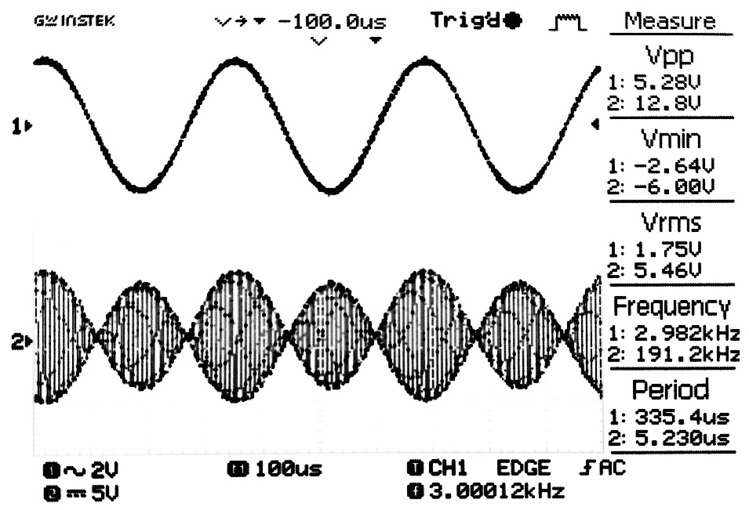**Waveform:**

**Fig:** Message signal

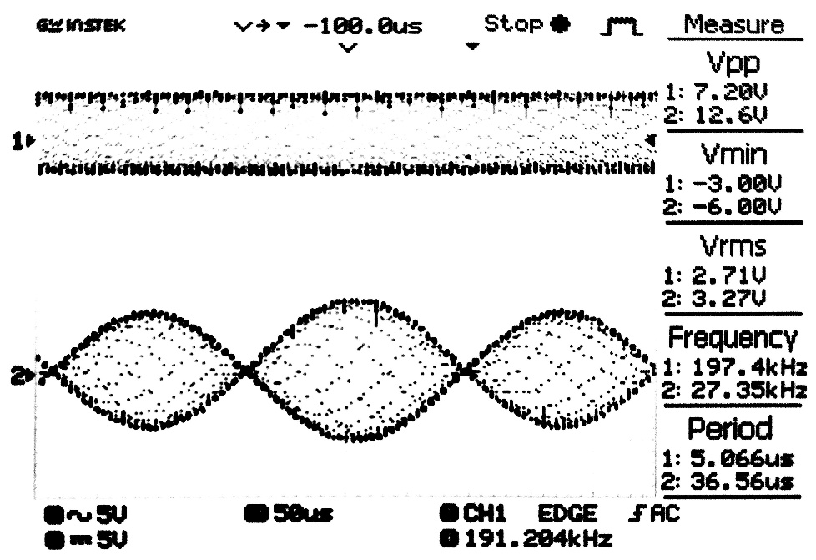

**Fig:** Carrier signal

**Discussion:** In this Experiment we created message signal using function generator and carrier wave using a given circuit and modulated the message signal using AM modulation